IT Ticket Analysis Objective & Subjective Answers

BY: Amanjeet Saroha

**Objective Questions**

1. **What is the total no. of attributes present in the data?**

In ticket worksheet total no of attributes present are: 10

In IT agent worksheet total no of attributes present are: 6

In total there are 16 attributes present in the table

1. **Which columns have inconsistent or missing values, and what is the count of such values?**

There are no inconsistent or missing values in the given data

1. **What is the average daily ticket volume over time?**

To calculate The average daily ticket volume over time, we need to calculate the total no of tickets by using =COUNTA(Tickets[ID Ticket]) formula. And to calculate no. of days, we use =COUNTA(UNIQUE(B:B)), So The average daily ticket volume over time is

= Total No. of ticket/No. of days

=97498/1827

=53.365. or ~53

1. **What is the distribution of ticket categories (e.g., Login Access, System, Software)?**

The distribution of ticket categories are as follows:

|  |  |
| --- | --- |
| **Ticket Category** | **No. of Tickets** |
| Hardware | 9733 |
| Login Access | 29193 |
| Software | 19570 |
| System | 39002 |
| **Total** | **97498** |

1. **How many tickets has each agent handled?**

The following table provides information regarding the no. of tickets handled by each agent.

|  |  |  |
| --- | --- | --- |
| **Agent ID** | **Agent Name** | **Tickets Handled** |
| 1 | A. Trejo | 1969 |
| 2 | Alberto Casillas | 1968 |
| 3 | Alberto Gastelum | 2021 |
| 4 | Aldo Carrillo | 1988 |
| 5 | Alfonso Barraza | 2000 |
| 6 | Alfredo Barreras | 1949 |
| 7 | Armando Sierra | 1935 |
| 8 | Aurelio Tanori | 1960 |
| 9 | Barbara Grijalva | 1949 |
| 10 | Barraza Alberto | 1974 |
| 11 | Darwin E. | 1956 |
| 12 | Diana Rojo | 1897 |
| 13 | Eduardo Luna | 1856 |
| 14 | Elena Velez | 1942 |
| 15 | Enrique Montiel | 1991 |
| 16 | Estuardo Ocaño | 1926 |
| 17 | EstuardoTorres | 1961 |
| 18 | Eva Cardenas | 1892 |
| 19 | Flores Sierra | 1984 |
| 20 | Galindo Guadalupe | 1920 |
| 21 | Griselda Galindo | 1889 |
| 22 | Guadalupe Hernandez | 1966 |
| 23 | Guadalupe Torrico | 1915 |
| 24 | Guadalupe Villanueva | 2003 |
| 25 | Isela Leyva | 1906 |
| 26 | Javier D. | 1963 |
| 27 | Jesus Contreras | 1968 |
| 28 | Jesus Pacheco | 1946 |
| 29 | JesusGrajeda | 1931 |
| 30 | Leon Lourdes | 1963 |
| 31 | Lopez Moran. | 1987 |
| 32 | Lorena | 1974 |
| 33 | Luis Arguello | 1958 |
| 34 | Luis Torres | 1927 |
| 35 | Marisol Piedrahita | 2007 |
| 36 | Mata Lucero | 1913 |
| 37 | Melinda | 1931 |
| 38 | Miller Gaviria | 1938 |
| 39 | Nurio Zepeda | 2026 |
| 40 | Orci Carlos | 1920 |
| 41 | Parra Luna | 1966 |
| 42 | Ramon Macias | 1945 |
| 43 | Reyna Santacruz | 1897 |
| 44 | Rosa Olguin | 1943 |
| 45 | Sandra Lujan | 1929 |
| 46 | Segura Garcia | 1950 |
| 47 | Silvia Morales | 1933 |
| 48 | Velasquez Jose | 2027 |
| 49 | Willyberto Gonzales | 1890 |
| 50 | Yomaira Agudelo | 1949 |

Each agent has handled an average of 1949.96 tickets. As there are 50 agents and total number of tickets are 97498

1. **How can you extract the domain from the email addresses in the IT Agents sheet?**

To extract the domain from the email addresses in the IT agents sheet we can use the **=MID([@Email],FIND("@",[@Email])+1,FIND(".",[@Email],FIND("@",[@Email]))-FIND("@",[@Email])-1)** function, it will extract the portion of text that appears after a specific character i.e ‘@’, and before the ‘.com’

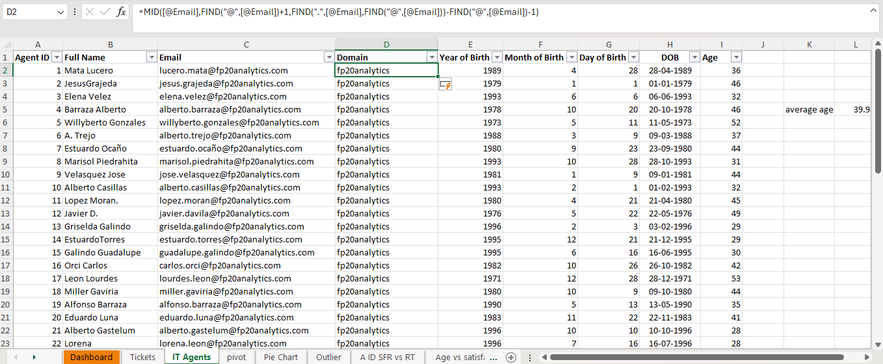

1. **How can you find the full name of an agent given their Agent ID?**

We can find the full name of an agent given their Agent ID by using VLOOKUP function in excel.

i.e =VLOOKUP([@[Agent ID]],IT_Agents[[#All],[Agent ID]:[Full Name]],2,0)

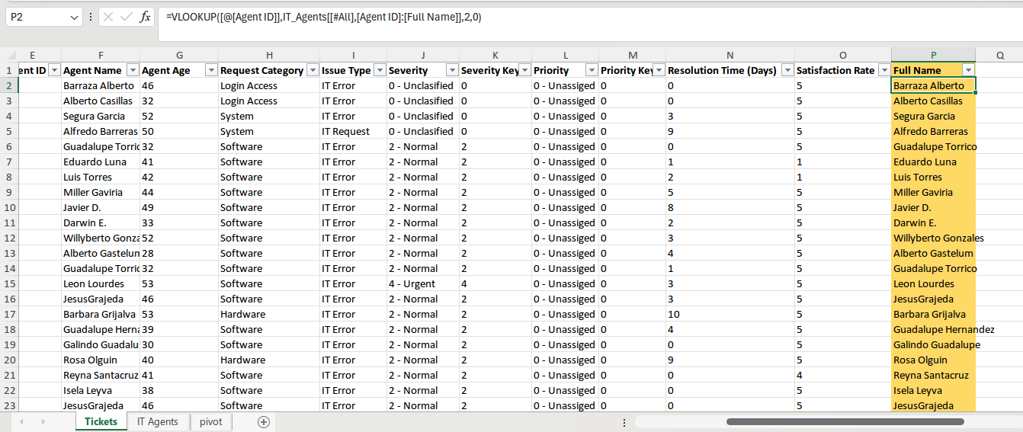

1. **What is the count of each issue type (e.g., IT Error, IT Request)?**

The count of each issue type is as follows in the below table;

|  |  |
| --- | --- |
| **Issue Type** | **Number of Tickets** |
| IT Error | 24278 |
| IT Request | 73220 |
| **Grand Total** | **97498** |

1. **What is the daily average resolution time for tickets?**

The daily average resolution time for can be calculated by the following formula:

I used =AVERAGE(Tickets[Resolution Time (Days)])

= 4.55 days

1. **How has the volume of tickets changed over time?**

The volume of tickets has changed significantly over time. As we can see in the below charge that the number of tickets has increased to 29088 in the year 2020 from 13051 in the year 2016

1. **What is the average age of the IT agents?**

To calculate the average age of the IT agents, firstly we need to find the date of birth of each agent first by DATE() function.

After calculating date of birth we use DATEDIF() function to calculate the age of the agents.

i.e = DATEDIF(G2,TODAY(),"y")

So, the average age of it agents is: 39.88 years

1. **Is there a correlation between the severity of issues and the resolution time?**

To identify the correlation between the severity of issues and the resolution time we need calculate this using =CORREL($A$50:$A$97547,$C$50:$C$97547) function in pivot worksheet.

Taking the numeric component of severity as first parameter and resolution time as the other, we get correlation as **-0.04.**

This numeric value represents that there is no linear correlation, which means that with increasing severity of issues, the resolution of time may or may not increase.

We can also see in the chart that the curve is not increasing in a liner manner, representing that there is a non- linear relationship between resolution time and severity.

1. **How many categorical columns are there in the data? [Search about categorical and continuous data, and try to answer this question]**

The categorical columns present in sheet Tickets are 7. i.e

In Tickets sheet there are 5 categorical columns:

**ID Ticket**

**Request Categories**

**Issue Type**

**Severity**

**Priority**

There are 2 categorical columns in the sheet IT Agents.

**Full Name**

**Email**

**Subjective Question**

1. **If there is an investment, should it be used to hire more IT agents, improve training programs, or upgrade ticket management software?**

**Analysis: Perform a cost-benefit analysis using ticket resolution and satisfaction metrics.**

To determine whether to invest in hiring more IT agents, improving training programs, or upgrading ticket management software, a cost-benefit analysis was conducted based on key metrics like ticket resolution time and satisfaction rate. Data from the "Satisfaction and Resolution" sheet indicates an **average satisfaction rate of 3.61** and an **average resolution time of 5.37 days**. These figures suggest room for improvement, especially in reducing resolution times to enhance customer experience.

**Hiring more IT agents** is likely to reduce resolution times by increasing the team's capacity to handle tickets promptly. As the below line graph shows that the ticket volume keeps on increasing over the years. The variation in the handling of such tickets by limited agents can be a vital indication of hiring more agents as well as training them.

**Improving training programs** can enhance both satisfaction rates and resolution times. Skilled agents are better equipped to resolve issues efficiently and provide a superior customer experience. If agent-level data shows significant variance in resolution performance, targeted training can bridge these gaps. Additionally, training can address patterns identified in tickets, as seen in the "Tickets" or "Request Categories" sheets, to reduce repetitive issues.

**Upgrading Ticket Management Software**

**Severity vs. Priority Alignment:**

● The chart shows a significant portion of tickets categorized as "High Severity" but not consistently assigned to "High Priority."

● Similarly, "Urgent" issues still have some overlap with lower priority levels, indicating potential mismatches in ticket categorization and prioritization.

Unclassified and Misaligned Tickets:

● A noticeable percentage of tickets remain "Unclassified" or assigned to low-priority levels despite their severity. This suggests inefficiencies in the current ticket management system's ability to categorize and prioritize issues accurately.

Impact on Resolution:

● Mismatches between severity and priority may lead to delays in addressing critical issues, negatively affecting resolution times and customer satisfaction.

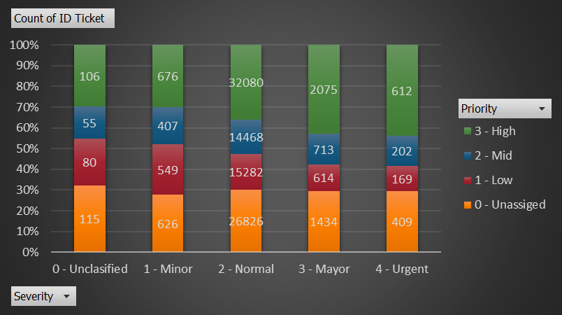

**Recommendation:**

Investing in upgraded ticket management software is a priority to address these inefficiencies. The new software should include:

● Enhanced Automation: Automatically assign priority levels based on severity to reduce human error and inconsistencies.

● Improved Categorization: Use AI or advanced algorithms to classify tickets more accurately.

● Customizable Workflows: Allow IT teams to adjust ticket handling processes for better alignment with business needs.

**Conclusion:**

A comprehensive review of the above factors will clarify which investment yields the best return.

For instance, if bottlenecks are caused by high workload and delays, hiring more agents is the most effective choice.

If inefficiencies stem from skill gaps, training should be prioritized. If tools are outdated, software upgrades may be critical.

A balanced approach, combining two or more options, might provide the best results for both resolution speed and customer satisfaction.

1. **Which agent needs additional training based on their performance metrics?**

**Analysis: identify agents with the lowest satisfaction ratings and longest resolution times.**

**Visualization:**

|  |  |  |  |
| --- | --- | --- | --- |
| **Agent ID** | **Agent Name** | **Average of Satisfaction Rate** | **Average of Resolution Time (Days)** |
| 6 | A. Trejo | 3.592611596 | 5.32067727 |
| 25 | Sandra Lujan | 3.601259182 | 5.204616999 |
| 28 | Nurio Zepeda | 3.612024666 | 5.409558068 |
| 3 | Elena Velez | 3.615042058 | 5.381989114 |
| 22 | Lorena | 3.628179044 | 5.511190234 |

**Insights:**

1. **A. Trejo (Agent ID 6)**

* Lowest satisfaction score: 3.59
* Resolution time: 5.32 days, slightly above acceptable levels.
* Indicates both service quality and efficiency concerns

1. **Lorena (Agent ID 22)**

* Longest resolution time: 5.51 days
* Satisfaction also low: 3.63
* Needs support in time management and technical troubleshooting

1. **Sandra Lujan (Agent ID 25)**

* Among lowest satisfaction: 3.60
* Slightly better resolution time (5.20 days) but still needs improvement

**Agents Needing Additional Training:**

* A. Trejo (ID 6) — Priority for both satisfaction and efficiency improvement
* Lorena (ID 22) — Priority due to longest resolution time
* Sandra Lujan (ID 25) — Recommended for service quality improvement

**Recommendations:**

1. **Targeted Performance Workshops:**

* Customer handling & communication for A. Trejo and Sandra
* Technical troubleshooting and time management for Lorena

1. **Mentoring Program:**

* Pair these agents with consistently high performers

1. **Close Performance Monitoring:**

* Weekly tracking of satisfaction and resolution metrics post-training

1. **Tool Training:**

* Ensure full understanding and effective use of ticket management software features

**Conclusion:**

Data clearly shows that A. Trejo, Lorena, and Sandra Lujan require additional training to improve both customer satisfaction and resolution efficiency. With focused support, their performance can align with organizational standards.

1. **Do certain categories of requests have longer resolution times?**

**Analysis: Analyse the resolution times by request category.**

**Insight:**

As per the analysis there are four different request categories as Hardware, Software, System and Login Access. Each request category has a different resolution time which is as follows:

Hardware - 7.63

Login Access - 0.31

Software - 5.24

System - 6.62

* Hardware and System requests exhibit notably longer resolution times than other categories, indicating potential process inefficiencies.
* These extended durations are likely due to greater technical complexity, reliance on physical components (for Hardware), and backend dependencies (for System).
* Login Access requests are resolved exceptionally fast, suggesting the presence of streamlined workflows or automation.
* Software issues show moderate resolution times, reflecting acceptable efficiency with room for further optimization.

**Recommendations:**

**Hardware and System Requests**

* Implement advanced diagnostic tools and adopt a proactive maintenance approach.
* Automate routine troubleshooting for hardware and system-related issues.
* Allocate dedicated resources and expert support to better manage these categories.

**Software Requests**

* Analyze frequent software-related problems that contribute to resolution delays.
* Develop self-service portals or automated solutions for resolving basic software queries.

**Login Access**

* Preserve the current setup, as it’s delivering excellent results.
* Evaluate the potential to replicate its automation success across other request types.

**Conclusion**

Hardware and System requests are the primary contributors to extended resolution times. To enhance overall IT support performance, it's essential to invest in targeted technologies, streamline processes, and optimize resource allocation for these categories.

1. **How effective are the current software tools in managing IT tickets?**

**Analysis: Evaluate performance metrics before and after the implementation of new tools.**

**Insights on Software Tool Effectiveness:**



1. **Persistent Priority-Severity Misalignment**

* A large number of Urgent Severity tickets (409 Unassigned, 169 Low Priority) show incorrect or missing priority assignments.
* Similarly, Major Severity tickets also have significant counts under Unassigned and Low Priority.
* Indicates manual errors or system limitations in enforcing logical priority assignment.

1. **Over-Reliance on Manual Categorization**

* High Unassigned counts across all severity levels suggest that the system does not auto-suggest or auto-enforce priorities effectively.
* Critical issues may go unresolved longer due to misclassification.

1. **High Volume Handling but Gaps in Accuracy**

* The system effectively handles large volumes (~97,000 tickets), which is positive.
* However, quality and alignment in classification lag behind.

1. **Possible Partial Improvements**

* High-priority counts (35,549) are strong overall, but inconsistent when broken down by severity.
* Suggests that while some improvements have been made, full automation or validation features may still be missing or underutilized.

**Conclusion on Current Software Effectiveness:**

* Current tools are adequate in terms of handling ticket volume.
* However, they lack sufficient automation, validation, or intelligent features to ensure accurate alignment between Priority and Severity.
* This can lead to delayed resolutions, especially for critical issues, undermining efficiency and customer satisfaction.

**Recommendations:**

1. **Upgrade ticket software to include:**

* Automated priority suggestions based on severity and ticket content
* Mandatory validation rules to block illogical Priority-Severity combinations
* Real-time dashboards highlighting misaligned tickets for management review

1. **Train agents on proper ticket categorization alongside system improvements.**
2. **How has the performance of the IT support team changed over time (e.g., monthly or quarterly)?**

**Analysis: Trend analysis using time series charts.**

The performance of the IT support team showed a clear upward trajectory between 2016 and 2020, as demonstrated by the steady growth in quarterly satisfaction ratings.

* **2016:**

Satisfaction scores were low, starting at 3.95 in Qtr1 and reaching 3.98 in Qtr4.

Possible causes: slower support resolution, outdated tools, or limited resources.

* **2017:**

Marked the beginning of improvement, with scores rising to around 4.06–4.08.

Likely due to better training or optimized support processes.

* **2018:**

Continued positive trend; Qtr1 peaked at 4.13.

Slight dip in Qtr2, followed by stable performance through the rest of the year.

* **2019:**

Maintained consistent satisfaction between 4.13 and 4.14 across all quarters.

Indicates reliable and steady service delivery.

In summary, the data highlights a long-term, positive shift in the IT support team's performance, marked by higher satisfaction rates and less volatility—indicating a more streamlined, reliable, and user-centric service model.

1. **If we invest more on tech (Hardware, software, etc), do you think it will improve the ticket resolution times and employee satisfaction?**

**Analysis: Use historical data to project potential improvements.**

**Observations from Historical Data:**

1. **Hardware**

* Longest resolution time (7.63 days)
* Satisfaction rate is stable but not excellent (4.101)
* Clearly an area where investing in better tools or infrastructure could significantly reduce resolution time

1. **Login Access**

* Fastest resolution time (0.31 days)
* Lowest satisfaction rate among all categories (4.095)
* Indicates that while speed is good, system usability or user experience may be lacking — software improvements could help

1. **Software**

* Moderate resolution time (5.24 days)
* Highest satisfaction rate (4.106)
* Shows that technology here is performing reasonably well, but resolution time still has room for improvement

1. **System**

* Resolution time is slow (6.62 days)
* Satisfaction is stable (4.102)
* Suggests backend processes or system-related tech could be upgraded to reduce delays



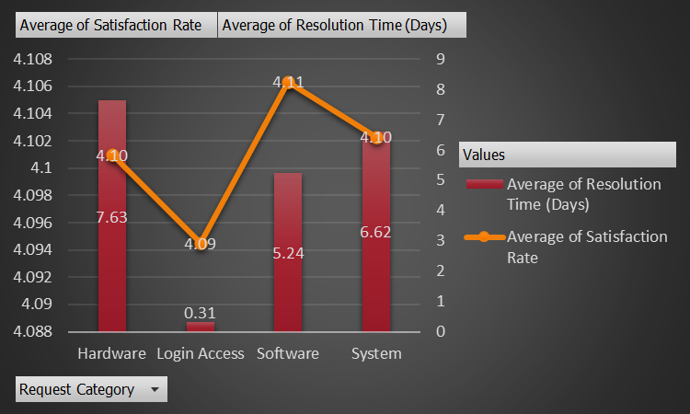

**Recommendations for Tech Investment:**

| **Area** | **Suggested Investment** | **Expected Impact** |
| --- | --- | --- |
| 1.Hardware | Better diagnostic tools, automated issue detection | Reduce resolution time significantly |
| 2.Login Access | Improve software interface & user instructions | Enhance satisfaction beyond speed |
| 3.Software | Automation of common troubleshooting steps | Faster resolution and sustained satisfaction |
| 4.System | System monitoring & backend process upgrades | Reduce downtime, improve satisfaction |

1. **What are the key performance metrics for IT agents, and how can they be improved, do we need to fire any agents?**

**Analysis: Define and analyze metrics such as average handling time, satisfaction scores, and number of tickets resolved.**

**Chart 1: Resolution Time vs. User Satisfaction**

* Resolution durations among agents vary between 3 to 6 days.
* Some agents exceed 5 days in resolution time and receive satisfaction scores below 4.0, highlighting potential performance concerns.
* A majority of agents fall within the 4.0–4.5 day range, paired with satisfaction ratings around 4.0 to 4.3—indicating stable performance.

**Insight:**

Certain individuals underperform in both speed and user satisfaction. These patterns may call for targeted interventions such as skill-building sessions or closer performance monitoring.

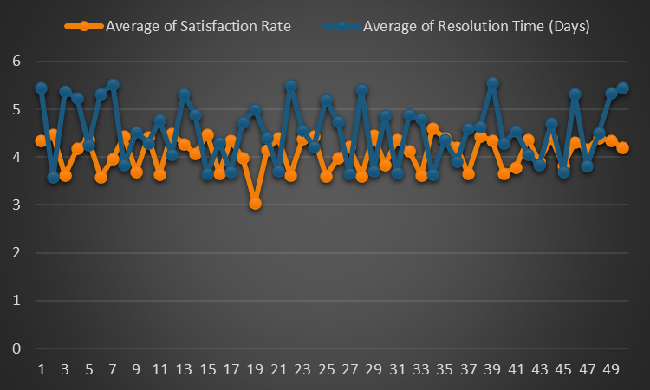

**Chart 2: Ticket Volume Per Agent**

* Ticket completion numbers range from approximately 1850 to 2050 per agent.
* This suggests a generally equitable workload distribution across the team.
* Agents with fewer completed tickets but also lower satisfaction or slower resolution speeds may require further evaluation.

Insight:

Efficiency isn’t just about ticket quantity. The top performers are those who balance a high ticket volume with strong user satisfaction ratings and timely resolutions.

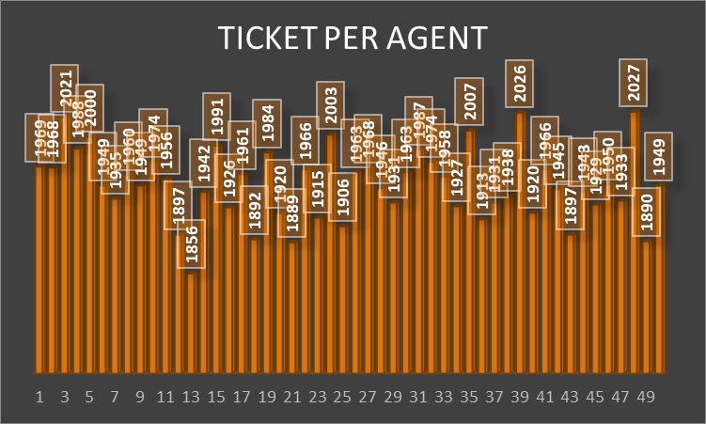

In Conclusion of both the charts, There are 50 agents in total who have handled 97498 tickets over 1827 days. Over this spam the average satisfaction rate was 4.10 and the average resolution time as 4.55 days.

The least average satisfaction rate value 3.59 is for Agent No 6 also the most average resolution time taken is 5.5 days by Agent No 22. Based on this analysis we can improve these agents skills with an additional training along with the below mentioned agents or decide to fire them if we are able to hire the right people



1. **How do employee demographics (e.g., department, seniority) impact satisfaction and ticket outcomes?**

**Analysis: Segment analysis using filters and pivot tables.**

We observe five distinct age groups — from 28 to 53 years — and their corresponding:

* Average Resolution Time (in Days)
* Average Satisfaction Rate (out of 5)

1. Age 33–37 has the highest resolution time (5.01 days) and lowest satisfaction score (3.96). This may suggest either:

* They are dealing with more complex cases,
* They may require upskilling or better tools to perform efficiently.

1. The 48–53 age group, likely to be more experienced, shows the lowest resolution time (4.11 days) and a high satisfaction score (4.20). This implies:

* Experience might contribute to quicker and more effective resolutions.
* Senior agents may have better knowledge of systems or tools.

1. The 28–32 group, possibly consisting of newer employees, also performs well (4.43 days, 4.21 satisfaction), suggesting a strong onboarding/training program or adaptability to tech tools.

In conclusion:  
Demographic segmentation reveals significant performance variations among age groups. While younger and older agents perform well, the 33–37 group appears to struggle, showing longer resolution times and lower satisfaction. These insights suggest the need for targeted training or support strategies. Segment analysis using pivot tables enables data-driven decisions for improving team performance and balancing workloads.

1. **Identify the trends for IT support operations based on ticket volumes and satisfaction, and mention the peak and stable times?**

**Analysis: Use pivot tables and charts to identify peak and off-peak hours.**

Trends in Ticket Satisfaction and Operational Patterns

1. Consistent Growth Over Time:

From 2016 to 2020, satisfaction rates steadily improved. Early years showed more variation, but by 2019–2020, scores were consistently above ~4.1suggesting greater operational stability and maturity.

2. Quarterly Behaviour Patterns:

* Q1 of each year typically shows a noticeable improvement year-over-year, reaching a peak of ~4.19 in 2020. This could reflect fresh initiatives or changes implemented at the start of each year.
* Q2 and Q3 maintained high ratings from 2018 onward, indicating sustained performance mid-year.
* Q4 remains relatively stable but occasionally dips slightly—perhaps due to end-of-year transitions, increased workloads, or system freezes.
* **Peak Satisfaction Periods:**
  + *Q2 2020 (4.18)* and *Q1 2020 (4.19)* mark the highest satisfaction scores, suggesting peak performance.
  + This period may reflect well-established processes, better tools, or increased staff effectiveness.
* **Stable Periods:**
* From *2018 onward*, most quarters remain within a narrow range (4.07–4.14), showing **consistency in service delivery**.
* Minimal fluctuation across quarters during 2019 also indicates strong operational control and balanced ticket loads.

Insights from Pivot Table & Time Analysis

* **Off-peak challenges** likely occurred in earlier quarters (e.g., Q1 2016–2017) with lower satisfaction levels (around 3.95–4.02).
* Pivot tables help correlate agent activity or ticket surges with lower satisfaction—possibly identifying training gaps or bandwidth issues.
* Departments or agents that handled more complex tickets during low-satisfaction periods may need workflow adjustments or system support.

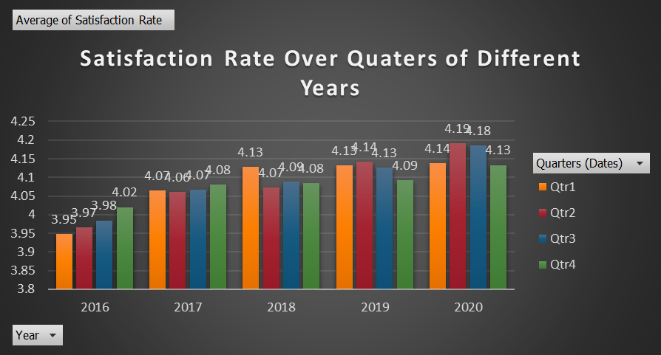

1. **What metrics should be included in the final dashboard to provide a comprehensive view of call center performance and guide investment decisions?**

To ensure the dashboard offers meaningful insights for both day to day operations and strategic decision-making, the following metrics should be included:

**Core Performance Metrics:**

1. Total Tickets

* Reflects overall workload handled by the IT support team

1. Tickets per Agent

* Measures workload distribution and helps assess staffing efficiency

1. Daily Ticket Volume

* Tracks ticket inflow trends for resource planning

1. Ticket Volume Over Time (Yearly/Monthly)

* Identifies growth patterns and seasonal spikes

**Quality & Efficiency Metrics:**

1. Distribution by Satisfaction Score

* Helps evaluate user experience and service quality

1. Average Resolution Time by Category

* Pinpoints which request types face delays and require process improvements

1. Distribution by Resolution Time

* Reveals efficiency patterns and highlights tickets with prolonged resolution

**Operational Breakdown Metrics:**

1. Request Category Distribution

* Helps management see which issue types dominate support demand

1. Severity and Priority Alignment

* Ensures critical issues are being prioritized appropriately

1. Age Group vs. Performance (Resolution Time & Satisfaction)

* Assesses agent performance across different demographics to guide targeted training

Conclusion:

The dashboard already covers most critical metrics, but ensuring these areas are emphasized or expanded with additional KPIs (where data is available) will make it a complete tool for both operational monitoring and informed investment decisions.

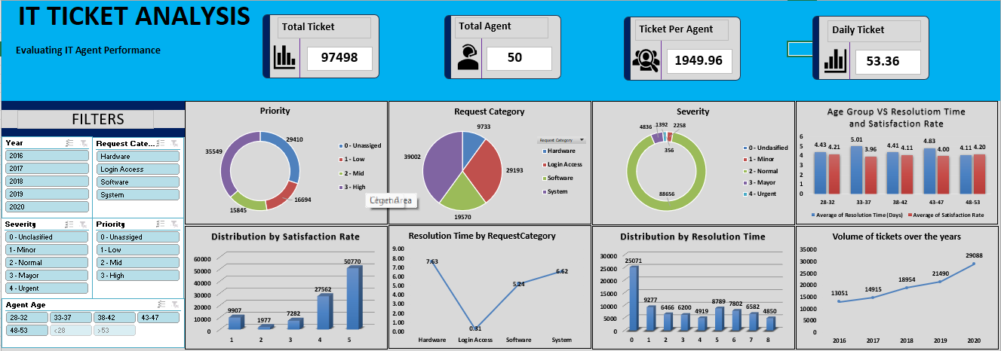

**Ensure that you put the slicers for choosing the priority wise and year in order to observe the dashboard since the management will be having a long discussion which can go for weeks.**

**Note: The dashboard would be more interactive and user-friendly, allowing management to explore data in detail and make informed decisions.**